Running Sum of 1D Array
class Solution {
public int[] runningSum(int[] nums) {
for(int i=1;i<nums.length;i++){
nums[i]=nums[i]+nums[i-1];
}
return nums;
}
}
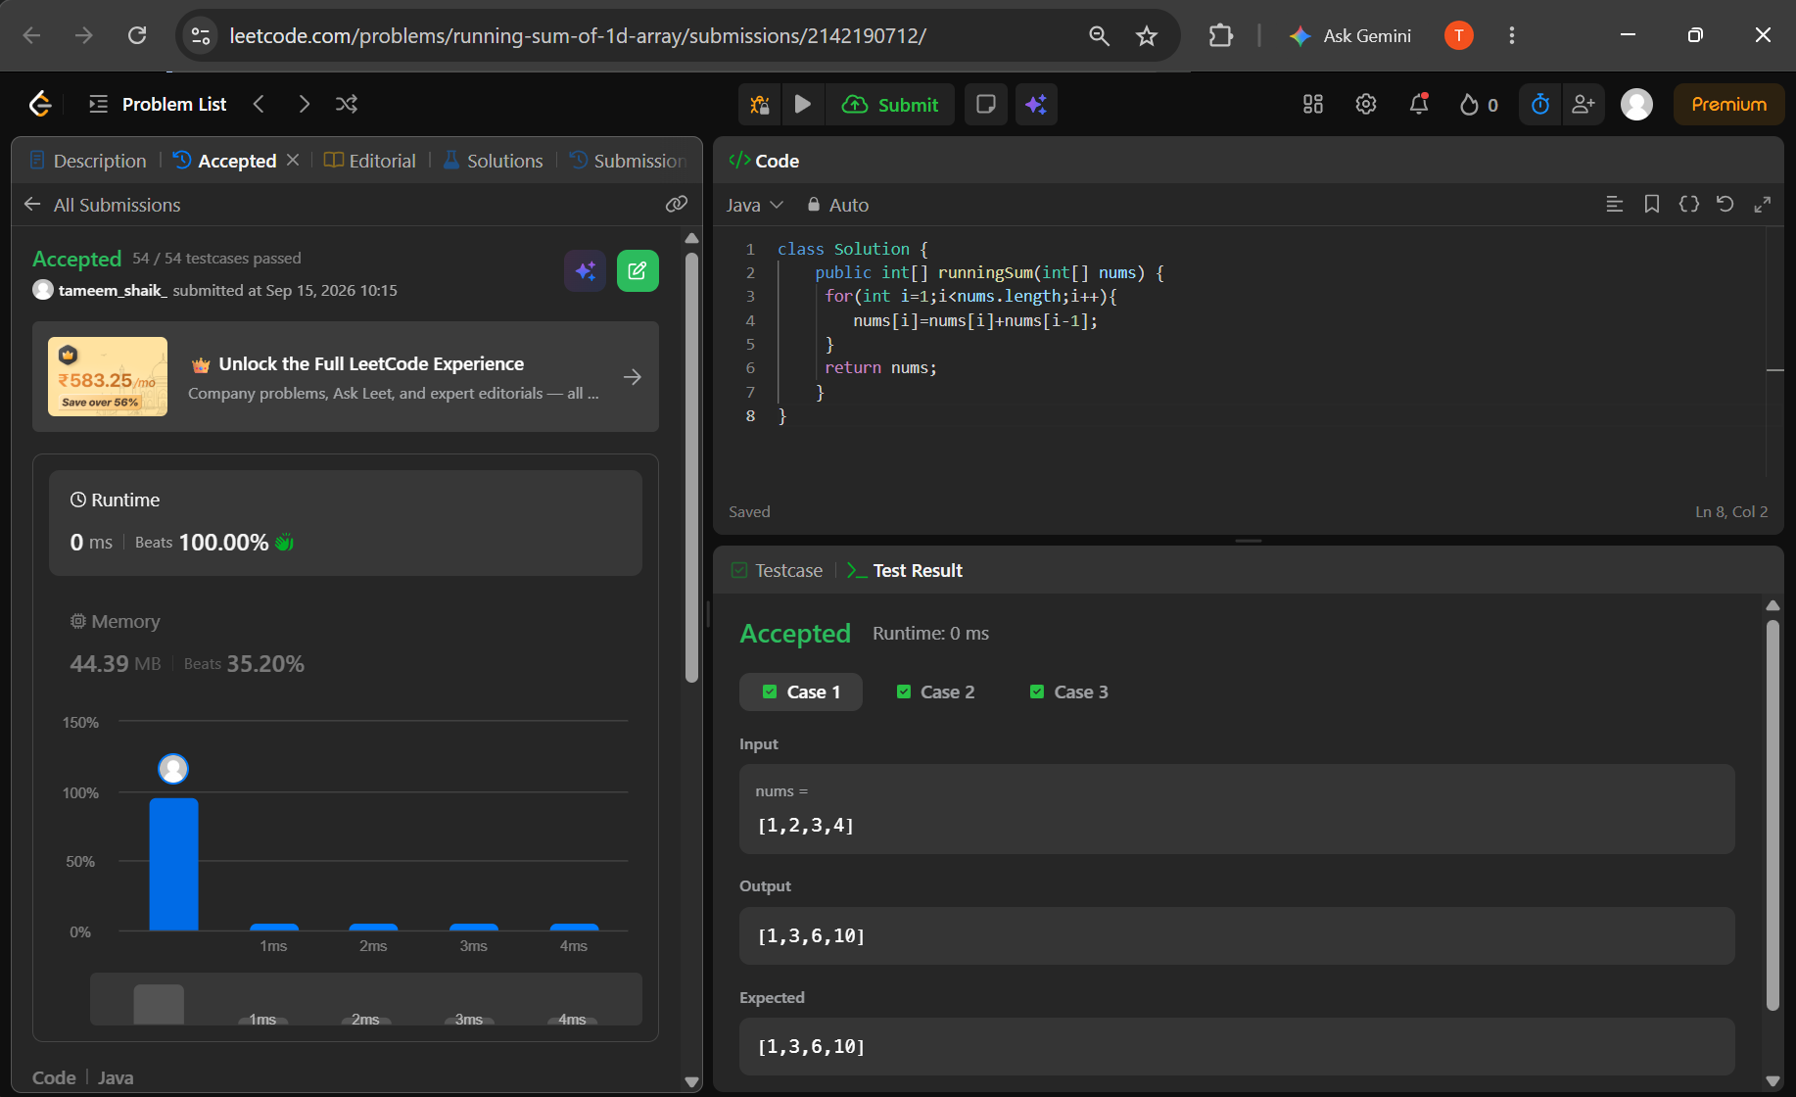

Richest Customer Wealth
class Solution {
public int maximumWealth(int[][] accounts) {
int maxWealth = 0;
for (int i = 0; i < accounts.length; i++) {
int wealth = 0;
for (int j = 0; j < accounts[i].length; j++) {
wealth += accounts[i][j];
}
maxWealth = Math.max(maxWealth, wealth);
}
return maxWealth;
}
}
